### **SPRINT 2**

Natural Disasters Intensity Analysis and Classification using Artificial Intelligence

**TEAM MEMBERS:**

412419104051-KAVANA RAO Y

412419104012-ARCHANA K

412419104128-SUDHARSHINY T A

412419104045-JOE MARIAM.J

412419104107-SAUJANYA K

**Home.html**

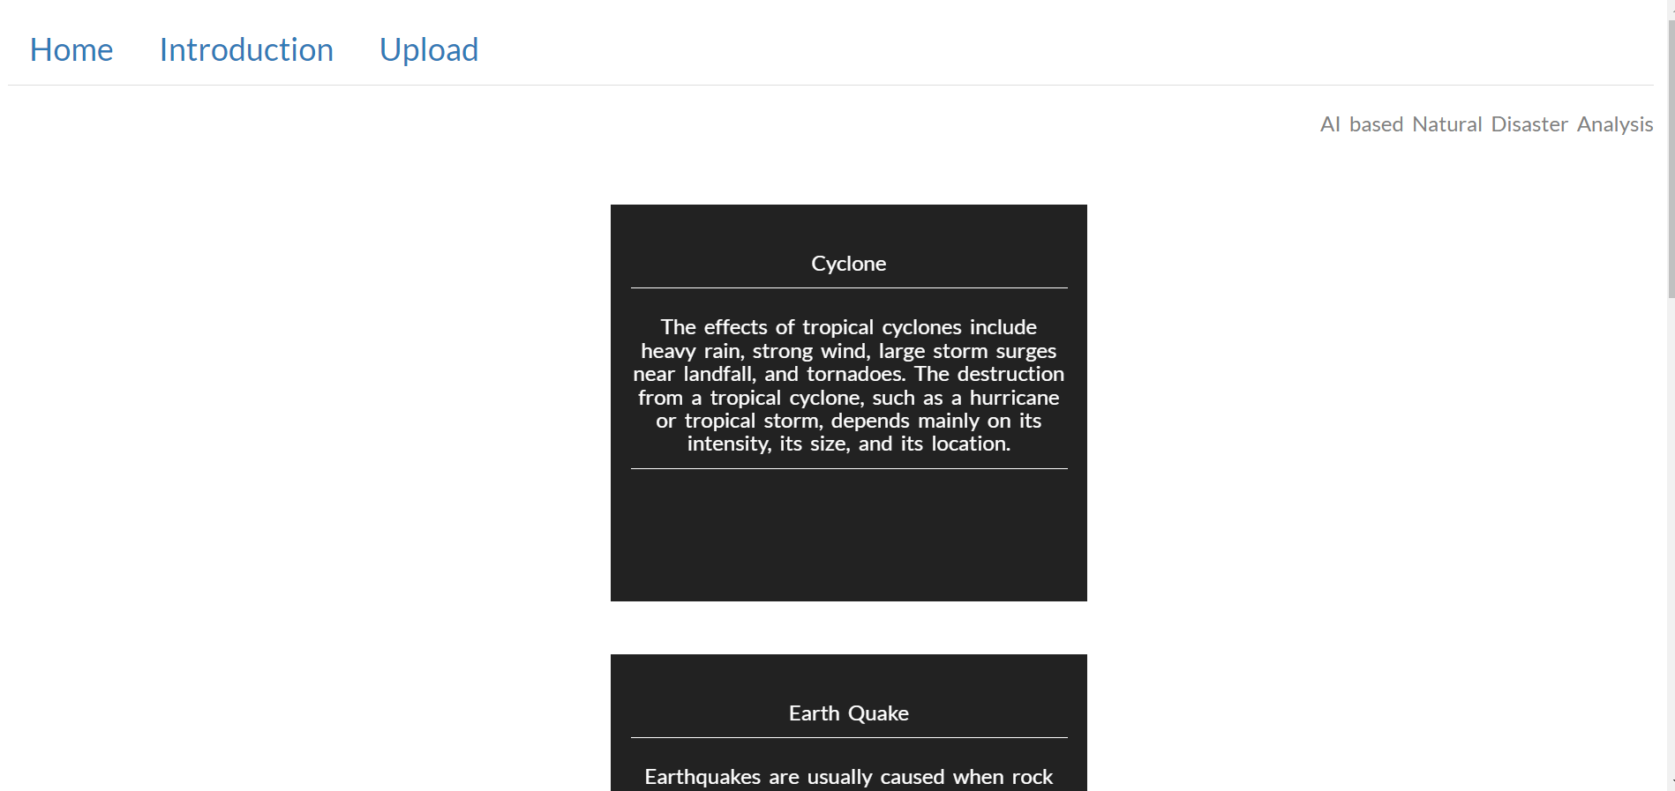

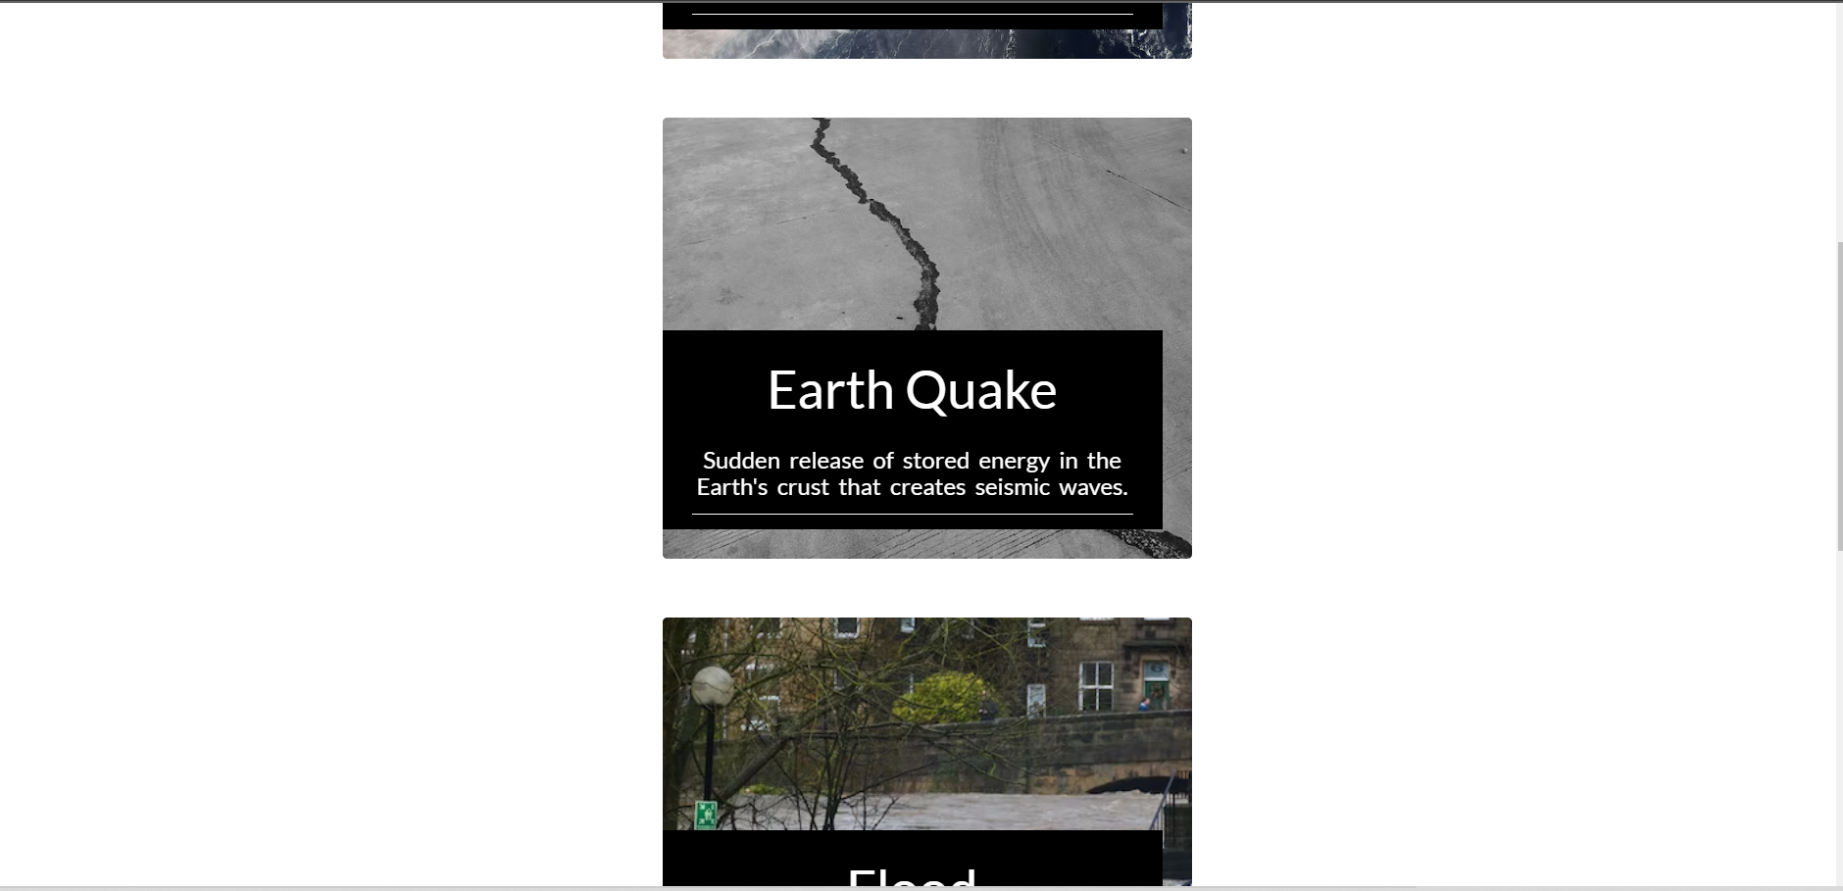

**Intro.html:**

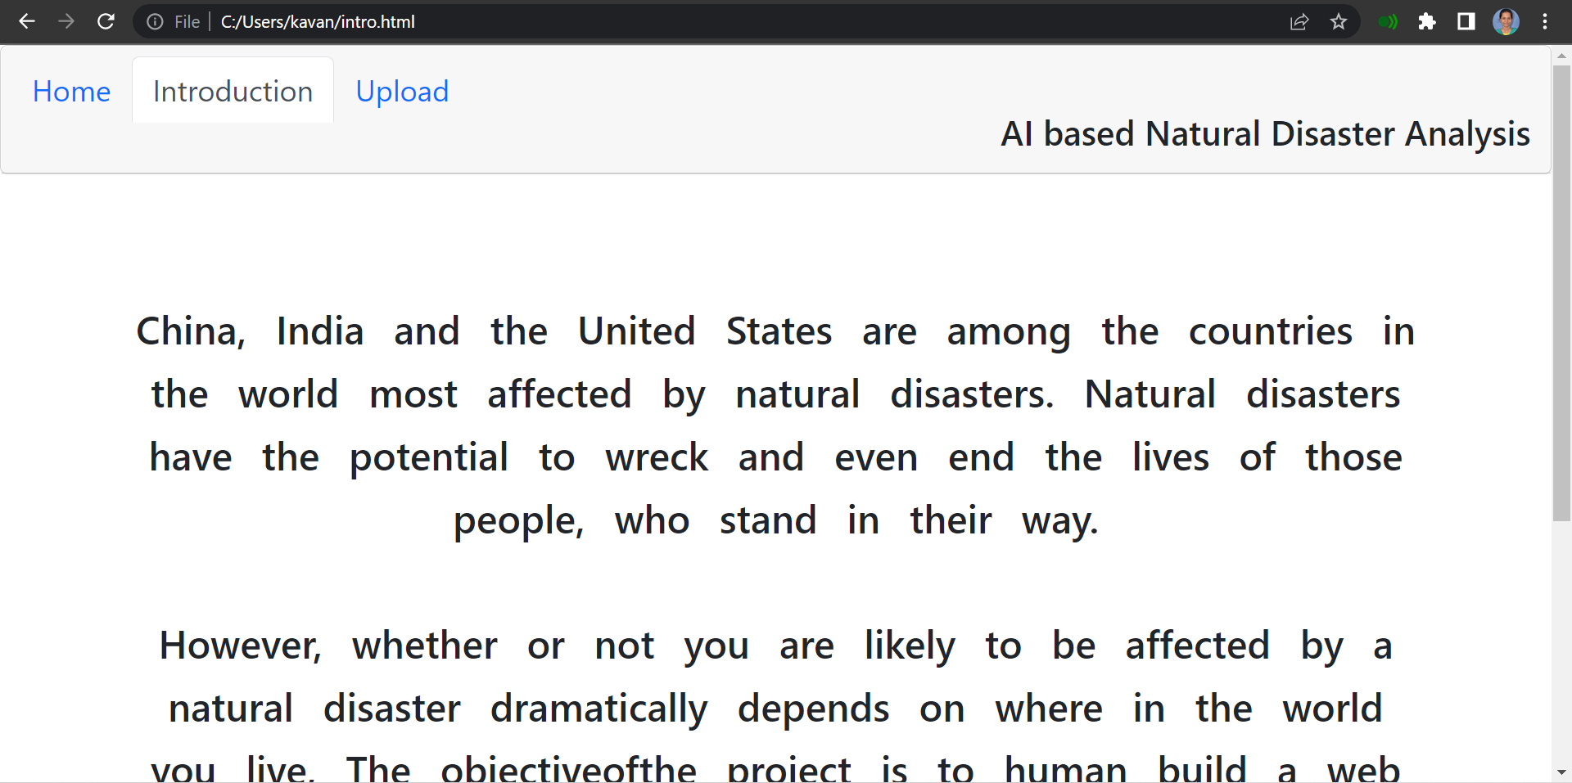

**Upload.html:**

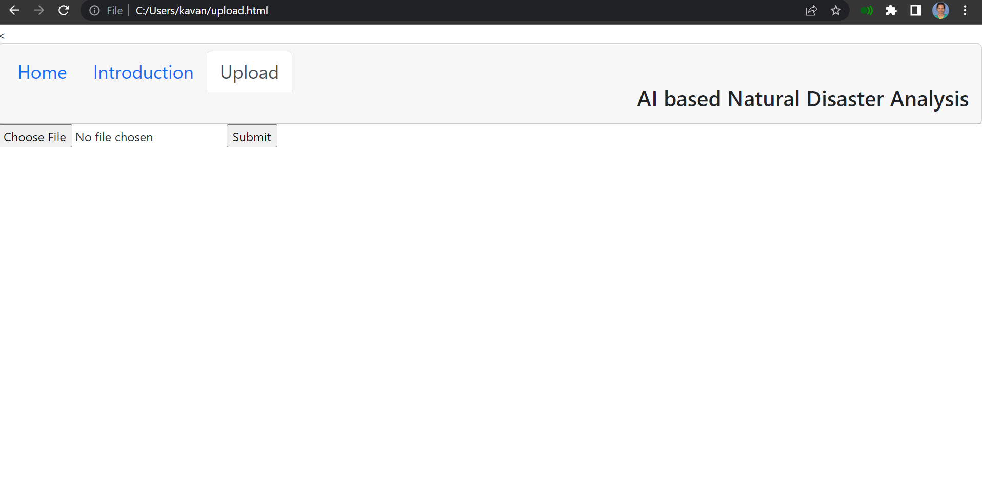

**Flask(application.py):**

